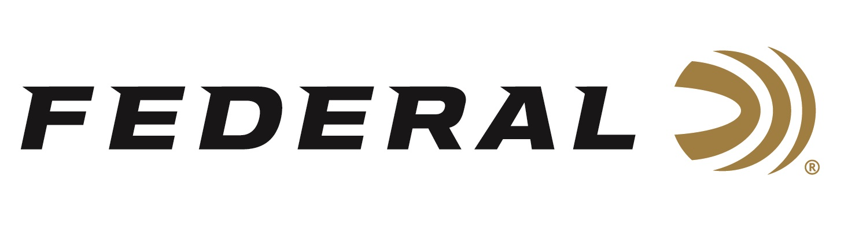

FOR IMMEDIATE RELEASE

Federal Recognizes Reeds Family Outdoor Outfitters with
President’s Award

ANOKA, Minnesota – March 31, 2021 – Federal Ammunition and sister brand Remington Ammunition announce the “President’s Award” to recognize an industry partner that has gone above and beyond normal business to elevate the hunting and shooting sports through acts of generosity, kindness, and advocacy. Jason Vanderbrink, President of Vista Outdoor Ammunition brands, has announced Reeds Family Outdoor Outfitters as the 2020 recipient of this prestigious award.

“It’s important to recognize the great work industry partners do for not only our products and brand, but what they do behind the scenes to further the mission of our industry,” says Vanderbrink. “I can’t think of better industry partners or more deserving than Jeff, Adam and Andrew Arnold at Reeds.”

In 2020, when conservation groups were struggling to complete their mission work without the traditional in-person banquets, the Reeds team stepped forward to allocate and subsidize ammunition to conservation groups for raffles that helped offset the loss of banquet revenue.

“The Reeds team is truly honored to receive this prestigious award,” says Adam Arnold, CEO. “We are truly humbled and honored by this award and appreciate the recognition of an act that was second nature to us,” stated Arnold. “When our industry friends and partners are in need of extra help, Reeds will be alongside them.”

To date, those efforts assisted in raising in excess of $300,000 dollars for conservation organizations to continue their missions of preserving habitat and flourishing wildlife populations. These organizations are vital in providing hunting and outdoor enthusiasts places to enjoy their passions and directly aligns with a core value in Federal’s mission.

Federal ammunition can be found at dealers nationwide or purchased online direct from Federal. For more information on all products from Federal or to shop online, visit www.federalpremium.com.

Press Release Contact: JJ Reich
Senior Manager – Press Relations
E-mail: VistaPressroom@VistaOutdoor.com

About Federal Ammunition
Federal, headquartered in Anoka, MN, is a brand of Vista Outdoor Inc., an outdoor sports and recreation company. From humble beginnings nestled among the lakes and woods of Minnesota, Federal Ammunition has evolved into one of the world's largest producers of sporting ammunition. Beginning in 1922, founding president, Charles L. Horn, paved the way for our success. Today, Federal carries on Horn's vision for quality products and service with the next generation of outdoorsmen and women. We maintain our position as experts in the science of ammunition production. Every day we manufacture products to enhance our customers' shooting experience while partnering with the conservation organizations that protect and support our outdoor heritage. We offer thousands of options in our Federal Premium and Federal® lines-it's what makes us the most complete ammunition company in the business and provides our customers with a choice no matter their pursuit.

